How to install NodeJs on Windows

1. Download NodeJs: <http://nodejs.org/>

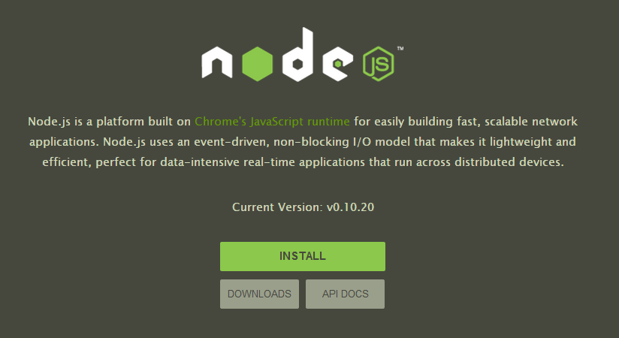

1. Open your command prompt and go to your nbdiff directory (example cd capstone/nbdiff)

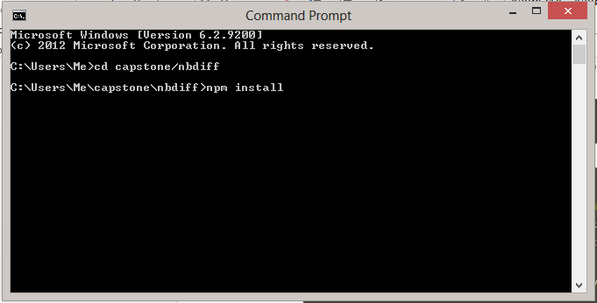

1. Type npm install and wait until it is installed.

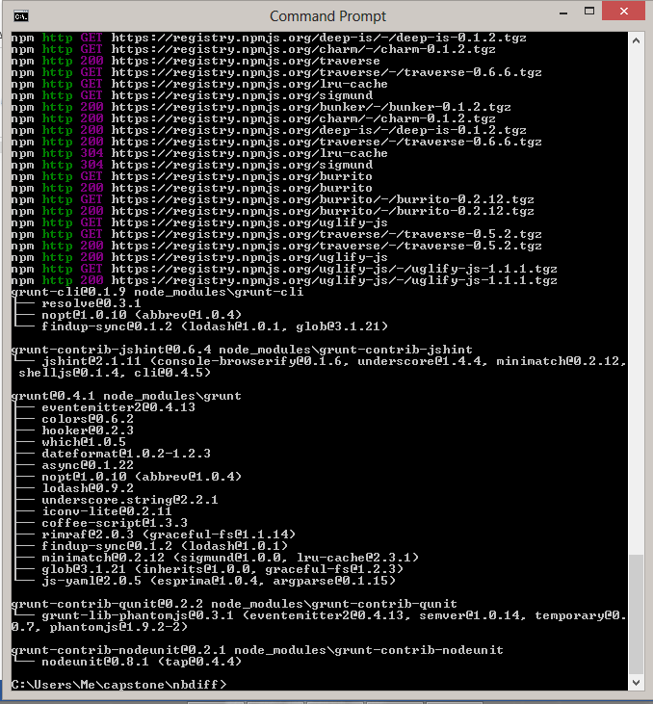

1. Open nodejs and do stuff…

